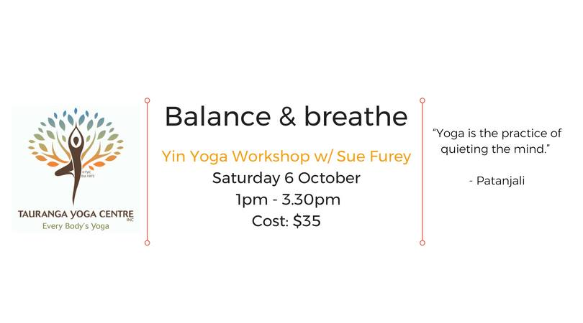

This Yin yoga practice will have a focus on 'balance and breath'

Yin can aid in increasing circulation into specific areas

Improves functional flexibility

Releases fascia (connective tissue)

Increases your 'self' awareness about body and mind interactions

A yin practice affords you the time to really explore and feel the asana and their effects on the mind, body and breath.

To register please email: fureys@kinect.co.nz: Pre pay to account no: 8-9004-0840024-00 or pay on the day

“Yoga is a light, which once lit, will never dim.

The better your practice, the brighter the flame.” B.K.S. Iyengar"

